**MINI PROJECT**

**EMBEDDED C PROJECT**

**TITLE**

CAR TEMPERATURE CONTROL

**SUBMITTED BY**

ATUL SINGH

**DATE**

APRIL.2022

**SUBMITTTED TO**



**ABSTRACT**

Temperature control refers to the processes that are aimed at maintaining the temperature in a given area at certain maximum/minimum level or within a certain range. Car buyers expect that climate control systems will make them comfortable. In order to control com fort and not merely climate temperature, one must first be able to estimate it.

This demonstrates that passenger body part equivalent temperature can be estimated using a multiple linear regression from environmental sensors and leads the way to comfort driven Heating, Ventilation and Air Conditioning control.

Equivalent Temperature is generally considered an accurate predictor for thermal comfort in car cabins. However, direct measurement of this parameter is impractical in fielded applications. The paper presents an empirical, multiple linear regression based approach for estimating body segment equivalent temperatures for car cabin occupants from different sensors within the car.

Thus for comfort heating system is used which is designed in such a way to fit in a car economically ,it takes less space and having low power consumption.

The Atmega328 microcontroller used in this project is programmed to optimise temprature as condition changes to full fill need.

**INTRODUCTION**

WHAT IS A TEMPERATURE CONTROL SYSTEM?

**Temperature:**

This is the degree of hotness or coldness of a body or an environment.

**Control System:**

The heat manage gadget is largely used to control the temperature of a vehicle seat. when a person or motive force of the car receives seated on a automobile, the button sensor receives activated. After that, the consumer gets access to show on the heater. The temperature sensor continues monitoring the temperature and sends the analog fee to the microcontroller. The microcontroller strategies the analog enter of the temperature sensor and outputs a temperature cost thru serial verbal exchange. all the activities of the manipulate gadget are carried out on a microcontroller called Atmega328.

Temperature Control System is a more like a programmable thermostat that can keep the temprature at a desired temperature regardless of fluctuating exterior weather conditions. The advantage of having a car temperature control system over a common thermostat is that it saves energy and money by automatically maintaining different temperatures at different times of the day and night. It is usually a feedback system having a control loop, including sensors, control algorithms and actuators/effectors, and is arranged in such a fashion as to try to regulate a variable at a set point or reference value.

**HISTORY OF TEMPERATURE CONTROL SYSTEMS**

The use of automatic Temperature manipulate structures commenced way returned in the 18th Century. The idea become conceived through Warren S. Johnson even as he changed into coaching at Norman college, Oklahoma. earlier than then, Janitors had to enter each study room to determine if it became too warm or too bloodless, after which alter the dampers inside the basement as a consequence. Johnson sought a manner to quit, or as a minimum reduce the lecture room interruptions of the janitors and increase the consolation stage of the students. the automatic Temperature manage system become to satisfy this very need.

In 1883 Warren Johnson gave up teaching to completely commit his time to learning and developing his thoughts. He moved to Milwaukee and formed the Johnson electric carrier business enterprise in 1885. In 1895, Johnson patented the pneumatic temperature control gadget. This allowed for temperature control on a room through room basis in homes and homes. It was the first such tool of its type. by the early 20th century the automatic Temperature manipulate device changed into being used in many notable places which include the New York inventory trade, Palaces of Spain and Japan, West point, the Smithsonian, the us Capitol constructing, and the house of Andrew Carnegie. using this gadget has increased continuously to this present day

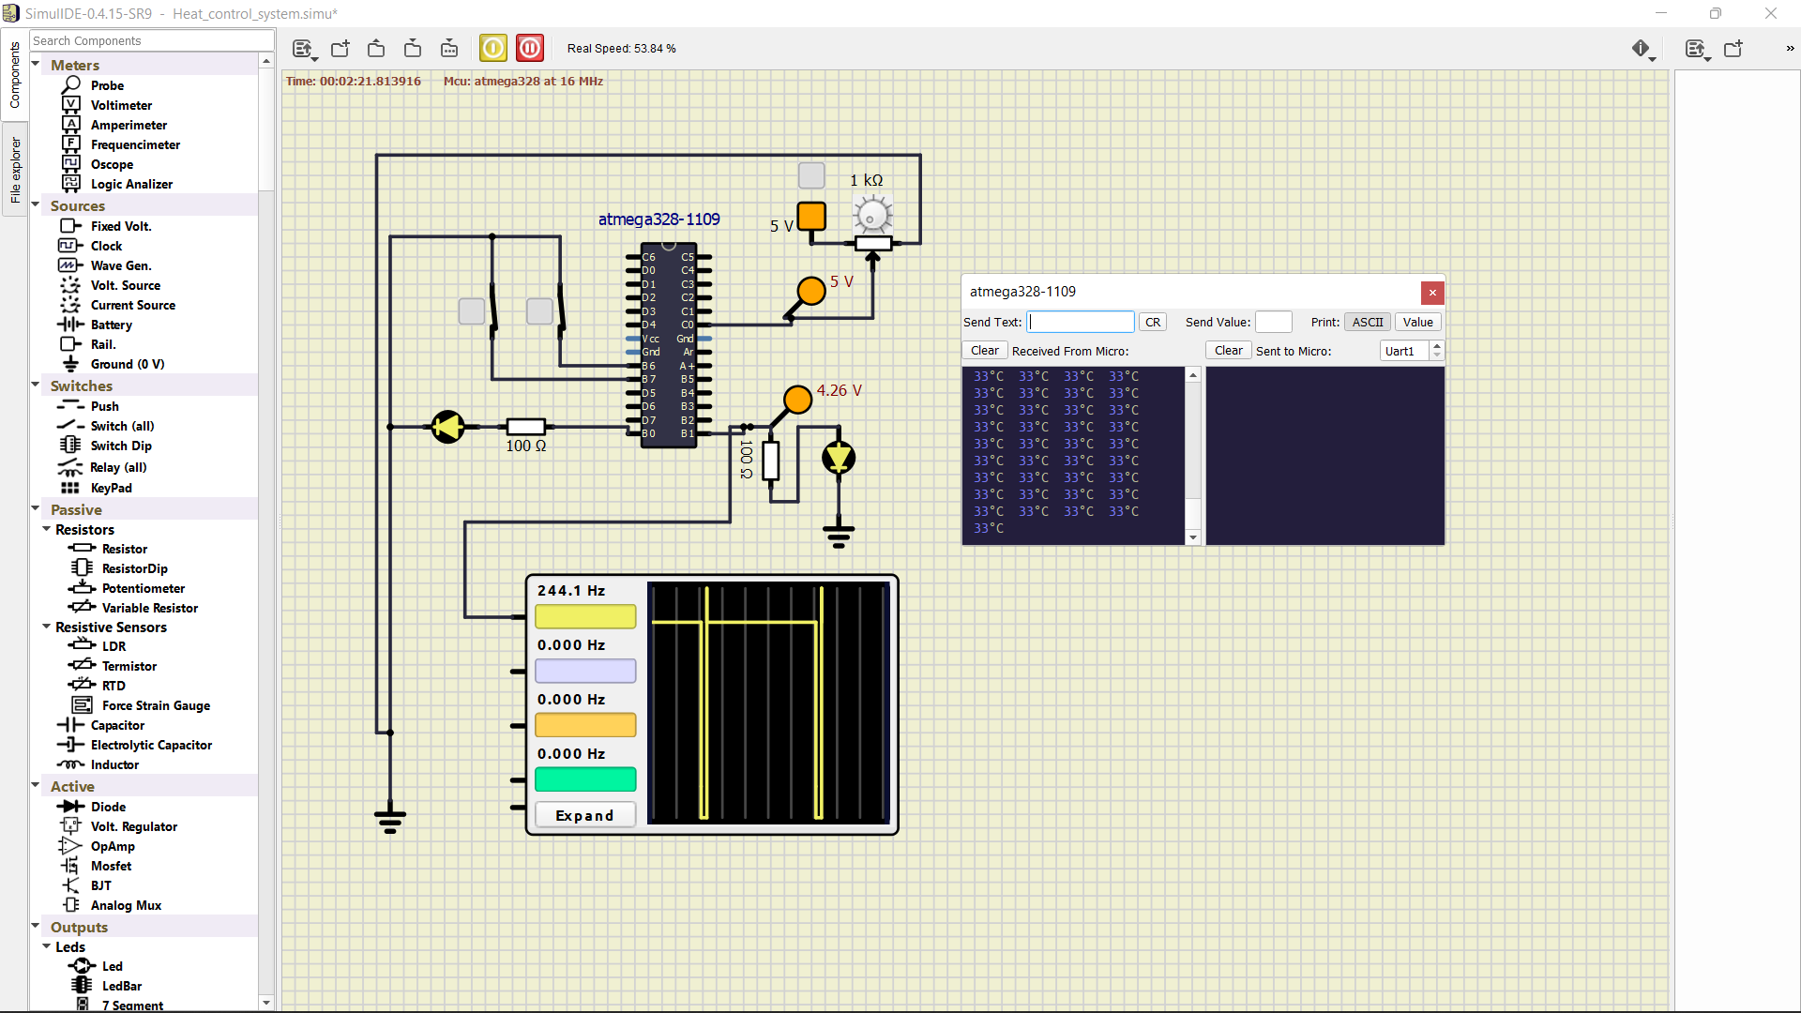 **OBJECTIVE OF THE PROJECT**

The main objective of this project is to design a Temperature Control System that helps to costumer for teamprature controlling automatically.It not only provide easy interface to control the teamprature nut also automatic temprature controlling which improve smartness of car.To achieve this, a highly sensitive Temperature sensor detects the current temperature and feeds it as input to the Micro-controller.The Micro-controller then initiates a sequence of control procedures based on the configuration of the control program it contains.These control procedures would include: turning on/off a heating or cooling**.**

**BASIC COMPONENTS OF A CAR TEMPERATURE CONTROL**

**HARDWARE**

* Atmega 328
* Variable Resistor 1 kOhm
* Pair of 100 ohm Resistors
* Pair Of Switch
* CRO( To Show Temprature in Graph)
* Serial Monitor (Actual Temprature Value)
* LED(2)
* 5v DC Supply
* Pair of Probe (Measure Terminal Voltage)
* GROUNDING

**SOFTWARE**

* MICROCHIP STUDIO
* VS CODE
* SIMULIDE

**COMPONENTS**

**1. ATmega 328 :-**

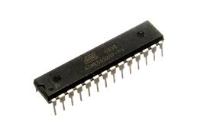

ATmega328 is commonly used in many projects and autonomous systems where a simple, low-powered, low-cost micro-controller is needed.The Atmel 8-bit AVR RISC-based microcontroller combines 32 KB ISP flash memory with read-while-write capabilities, 1 KB EEPROM, 2 KB SRAM, 23 general-purpose I/O lines, 32 general-purpose working registers, 3 flexible timer/counters with compare modes, internal and external interrupts, serial programmable USART, a byte-oriented 2-wire serial interface, SPI serial port, 6-channel 10-bit A/D converter (8 channels in TQFP and QFN/MLF packages), programmable watchdog timer with internal oscillator, and 5 software-selectable power-saving modes. The device operates between 1.8 and 5.5 volts. The device achieves throughput approaching 1 MIPS/MHz.

**2. VARIABLE RESISTOR:-**

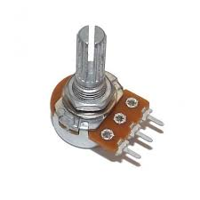A variable resistor is a resistor of which the electric resistance value can be adjusted. A variable resistor is in essence an electro mechanical transducer and normally works by sliding a contact (wiper) over a resistive element.

**3.RESISTOR;-**

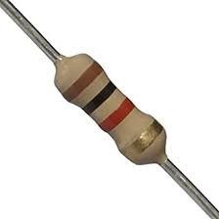

A device having resistance to the passage of an electric current.

**4.LED:-**

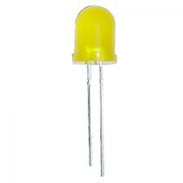

LED stands for light emitting diode. LED lighting products produce light up to 90% more efficiently than incandescent light bulbs. How do they work? An electrical current passes through a microchip, which illuminates the tiny light sources we call LEDs and the result is visible light.

**FUNCTIONALITY**

* when the 2 switches are closed, the primary LED glows indicating the actuation of the system and the heater.
* Next the analog input from the temperature sensor is received and digitized.
* The digitized temperature enter is visualized the use of Pulse Width Modulation.
* The corresponding temperature values based totally on the digitized temperature enter is transmitted by means of the UART protocol. right here the records is displayed on the serial screen.

**SIMULATION**

The capability of the warmth manipulate system is coded in embedded c and the running is validated the use of simuation in a software program known as SimulIDE. underneath suggests images in which within the 1st image suggests the repute of the simulation while the device is OFF and the second one image shows the repute of the machine while it's far ON.

**CIRCUIT DIGRAM**



**OPERATION**

**OUTPU**

**Circuit:**



**CRO:**

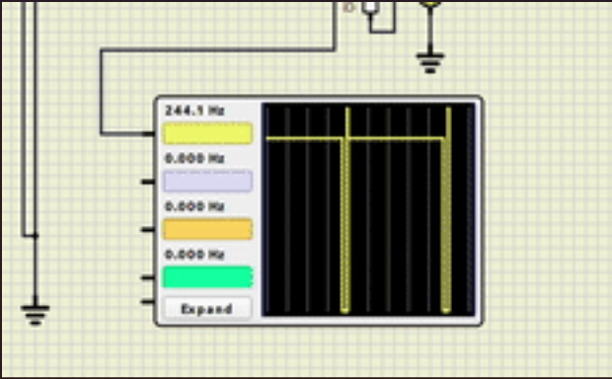

**SERIAL MONITOR:**

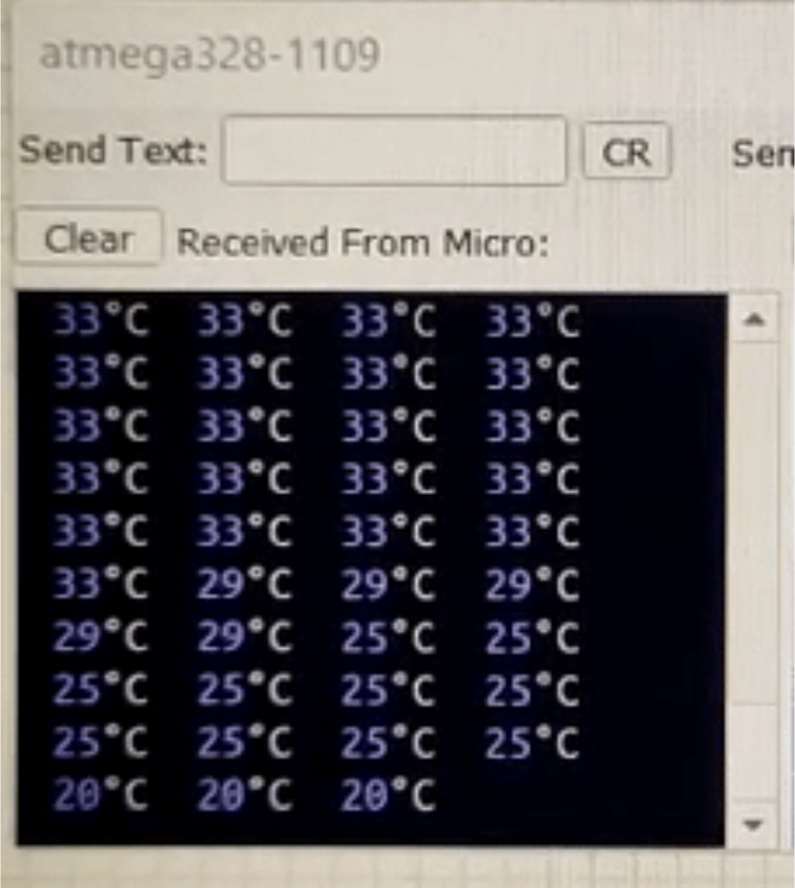

**PROJECT METHODOLOGY**

**The research methodology included the following steps:**

I. Study of previous literatures on the project to better understand the concept and functionality of the project.

II. Understanding the whole system of hardware and software sequences.

III. Designing the system circuit and developing the control algorithm.

IV. Testing the functionality of the various sections of the system.

V. Combining the both hardware and software components of the system.

VI. Documenting the Research/Project

**CONCLUSION**

**So we successfully implement car temprature control using ATMEGA328 in simmulide software .In this whole project we explored how embedded ‘c’ programming is done using microchip studio and creat HEX file and EXE file which we load in micro controller .**